
128
22-9
Final
NY
125
15-18
ATL

Full Scoreboard »
ABC 1-0
0-1
6:00 AM
NY SA

Jun 5

NBA
Gamecast Recap Box Score Play-by-Play Team Stats Videos

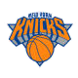Karl-Anthony Towns scores 36 and Jalen Brunson adds 34 as Knicks hold off struggling Hawks 128-125

By AP
Updated: Dec 28, 2025, 09:35 am

ATLANTA -- — Karl-Anthony Towns scored a season-high 36 points with 16 rebounds, Jalen Brunson had 34 points and the New York Knicks survived Atlanta’s late comeback attempt to beat the slumping Hawks 128-125 on Saturday night.

The Hawks lost their sixth straight to wrap up a crushing 0-5 homestand. Atlanta is 5-11 overall at home.

Towns made 17 of 18 free throws while helping the Knicks take a dominant 56-38 advantage in rebounds.

Nickeil Alexander-Walker, who scored 25 points, had a steal and basket with 48 seconds remaining to give the Hawks a 125-124 lead. OG Anunoby made two free
MATCHUPS
throws as the Knicks reclaimed the lead and, after he stole the ball following Trae
Young's pass, padded the lead with two more free throws.
NY le

Onyeka Okongwu led the Hawks with 31 points and 14 rebounds. Jalen Johnson recorded his 13th consecutive double-double with 20 points, 12 assists and nine rebounds before fouling out in the final minute.

NY

Gam

128

The Knicks held out forward Josh Hart, who suffered a right ankle sprain in Thursday's 126-124 win over Cleveland. Guard Deuce McBride (left ankle sprain) also was inactive.

“I hope I don't have to increase guys' minutes,” said Knicks coach Mike Brown before the game. Rookie Mohamed Diawara of France was the fill-in starter for

99

108

Ga

Gam

Hart.

Young, who had 30 points and seven assists in Friday night's 126-111 home loss to Miami, scored only nine points with 10 assists while playing back-to-back nights for the first time since missing 21 games with a right MCL knee sprain.

Anunoby had 15 points and 10 rebounds for the Knicks, who have won nine of 11 including two straight.

Up next

GAME INFORMATION

6:30 AM, Dece

State Farm Ar Atlanta, GA

Knicks: Visit New Orleans on Monday.

Hawks: Visit Oklahoma City on Monday.

AP NBA: https://apnews.com/hub/NBA

Attendance: 17

Where to Watc

FanDuel SN SE

Sponsored Headlines

High Blood Sugar? Eat This One Food Before Bed (Doctors Are Stunned)
Wellness Waves | Sponsored

Learn More
Oﬃciating Cre Referee: Brent Referee: Jacyn Referee: J.T. Or

Kirkland Products That Are Big Brands In Disguise
Decoist | Sponsored

2025-26 STANDINGS

Rare Photos Show Life On Hawaii's Forbidden Island
Outdoor Revival | Sponsored

Eastern Conference

ATLANTIC

Play War Thunder now for free
Fight in over 2000 unique and authentic Vehicles. Fight on Land, on Water and in the Air. Join the most comprehensive vehicular combat game. Over 2000 tanks, ships and aircraft.
Boston New York Toronto

War Thunder | Sponsored
Kia Syros: Made for your everyday drives
Spacious, smart, and safe - built to make every drive easy and comfortable.
Kia India | Sponsored
Play Now

Book Now

Philadelphia Brooklyn

Kia Syros: Smart features for every drive
From sunroof to smart tech, enjoy features that make every journey better.
Kia India | Sponsored

The 20 Most Educated Actors And The Degrees They Hold
Outdoor Revival | Sponsored

Book Now

SOUTHEAST

Atlanta Orlando Charlotte Miami Washington

Knee Pain Isn't Caused By Your Weight. The Real Reason May Surprise You
Wellness Waves | Sponsored

Learn More

Full

Next-to-skin, never in the way
Sweat hard, move fast, and let this handle everything in between
Trek Kit India | Sponsored

Indians over 65 are switching from hearing aids to this new device.
Recommended by audiologist
Hearing Aids | Sponsored

Learn More

Learn More

NBA NEWS

8
B
T
t b o

9

Term Plan for Self-Employed from ₹630/month
ICICI Pru IPS Super | Sponsored

Mountain Gear for Extreme Conditions
Shop the best in outdoor gear and apparel. High-altitude jackets, trekking boots, and more for your next adventure.
Trek Kit India | Sponsored

N
Get Quote M
T
t a r
Learn More 1

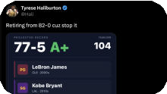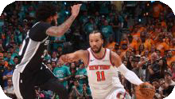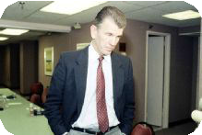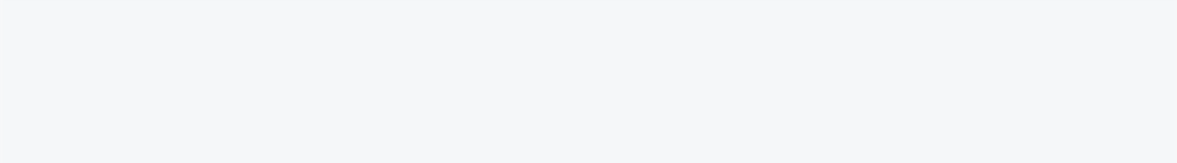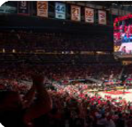

W C
P
r B A

1

All

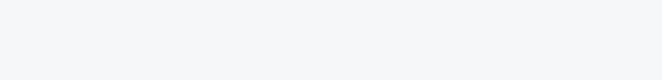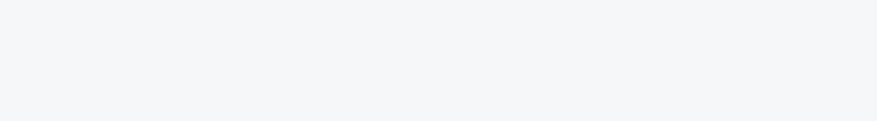


Terms of Use Privacy Policy Addendum to the Global Privacy Policy Interest Based Ads
Copyright: © ESPN Sports Media Ltd. All rights reserved.

